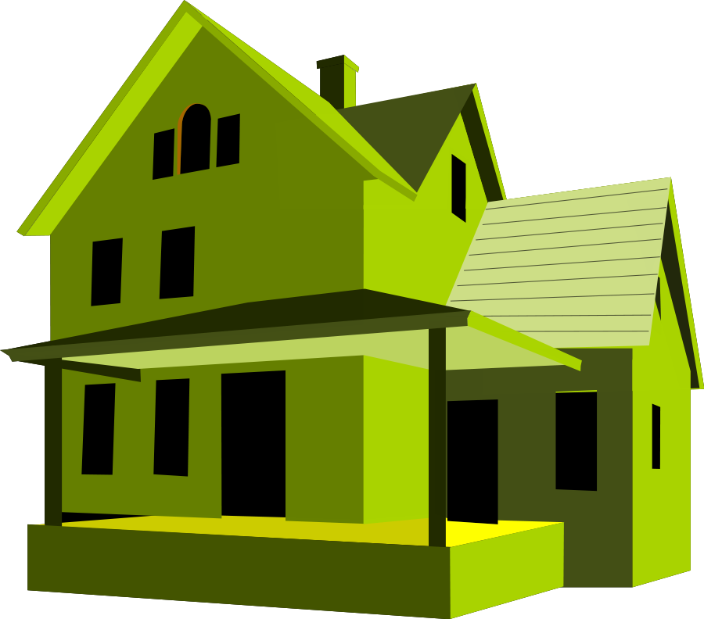

You have made it! Now it’s time to put everything you have learned to the test and to let your own creativity shine through!
This project with consist of 3 major parts. For each part, make sure that you when you hit the checkpoint you have your project approved by Ms. Miller.
Below are the requirements for each of the sections of the project! For each section you have 2 chances to revise before you begin to lose points, so make sure you confirm all requirements are included and complete before having your checkpoint checked-in
Good Luck & Have Fun

- Brainstorm what your dream home would look like. This should be a realistic house that is reachable for the future. You must include a list of 10 things that this house will
Include: Example: 3 bedrooms or a finished basement. Include a rough sketch (without scale) of what your floor plan will look like.
Checkpoint #1 /10 Pts

- Create your own floor plan using a ¼”=1’ scale using your rough draft as a guide.
Wall Height should be 8’-10’ minimum Doors should be 7’
Exterior walls should be a minimum of 7” Stairs should have a 3’ Width & 24” Depth
Interior walls should be a minimum of 4” Hallways should be a minimum of 4’ ½” wide

Your floor plan should include:
At least 7 different rooms (e.g. living room, bedrooms, bathrooms, etc)
Square footage for each room and a complete square foot total (create a key)
Proper labels for each room (e.g. living room, kitchen, etc.)
USING ALL CAPITAL LETTERING

At least 1 item in each room that is made for that room (e.g. utility room –washer and dryer), remember this is a floor plan the item should be a top view and labeled.

Color each area (living, sleeping, and service)
Label traffic patterns
1 room that requires tiles:
(These should be rooms that could require tiles: Kitchen, Bathrooms, utility rooms etc)
12x12= the same # as square feet
6x6= square feet multiplied by 4
3x3= square feet multiplies by 16
Checkpoint #2 Approved / Revise
Approved / Revise
Floor Plan Rubric
7 Different Rooms /10
Square footage for each room /10
Labels for each room /10
Individual item in each room (that goes with the room use) /10
Proper Area Colors (living, sleeping, & service) /10
Traffic Patterns Labeled /10
Rooms that require tiles have tile calculations /20
Neatness /30
Calculations /40

Total Grade: /150

Now it’s time to show me your creative side! Using your newly created Google email account information, go to www.floorplanner.com and login using Google. Now you are ready to create your 2D & 3D floor plan model.
Floorplanner.com is an amazing online drawing program that allows the user to draw real scale floor plans, add furniture and design elements, and view the plan in both 2D & 3D. It can be used anywhere there is a computer and the Internet!

You should include:
All of your rooms from your personal dream home floor plan
Add all of the furnishings for each of the rooms you have created
Be creative make it your own home
Print a 2D view of your floor plan (Ask before printing!)
Checkpoint #3 Approved / Revise
Approved / Revise Floorplanner.com
Rooms from original floor plan /10
Labels for each room /10
Individual items in each room (that goes with the room use) /10
Creativeness /10
Proper use of time /10

Total Grade: /50

Now that we know what it should look like, let’s build a 3D model. Using the materials given to you, build a 3D model of your house. Make sure that you follow all of the safety rules; this is your 1 and ONLY warning. If you misuse tools or break any of the safety rules, you will receive an automatic 0/F on your final exam project and receive any consequence due to school policy and procedures NO EXCEPTIONS!

You should:

Use your floor plan from part 1 as a base to build your 3D model
Your model should be on a ¼”=1’ scale
Add doors, windows, and walls to your floor plan building it in to a 3D model
Your walls should be no shorter than 10’ tall

*Make sure that you cut in your windows and doors before securing your walls down to the foundation*
Checkpoint #4 Approved / Revise
Approved / Revise
Final 3D Build
Includes 7 Different Rooms /10
Square footage for each room /10
Total Square Footage (KEY) /10
Labels for each room /10
All information is in CAPITAL LETTERS /10
Individual item in each room (that goes with the room use) /10
Proper Area Colors (living, sleeping, & service)(KEY) /10
Traffic Patterns Labeled /10
Rooms that require tiles have tile calculations /20
Calculations are correct /10
Neatness /20
Proper use of time /30

Total Grade: /160

